* Create a Virtual machine in AWS for Docker installation
* What is Docker container life cycle
* How to create a Containers and to load the images into containers
* Upload the images into Docker hub

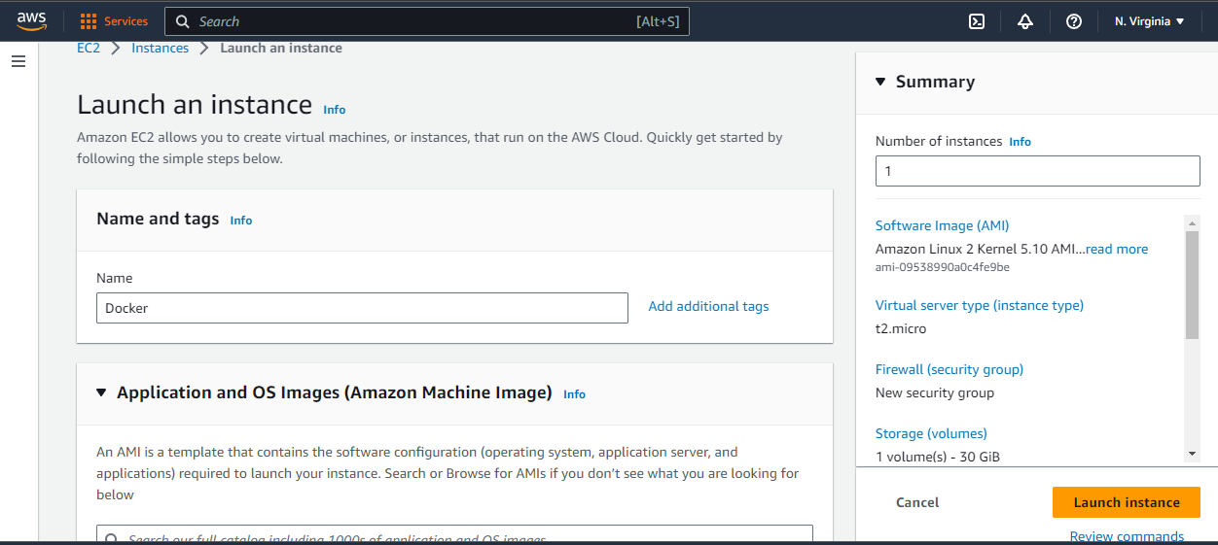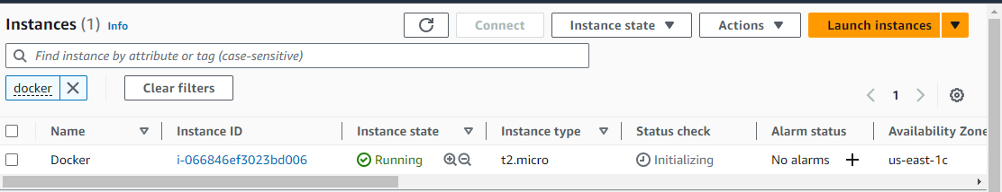

It required some update to install the docker in the Instance so used the “**sudo yum update -y”** command.

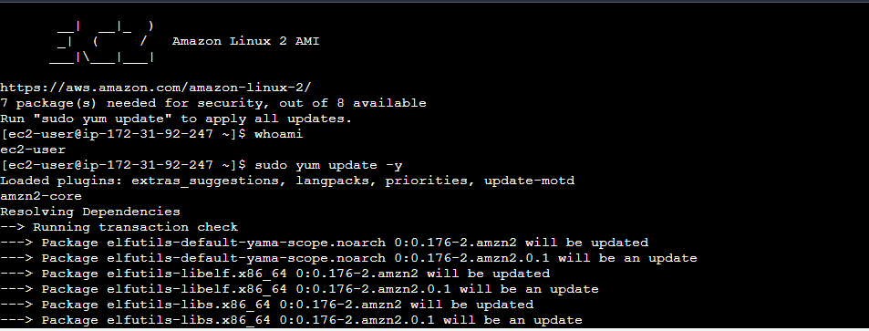

First became to change a Root user use the command **“Sudo su”**

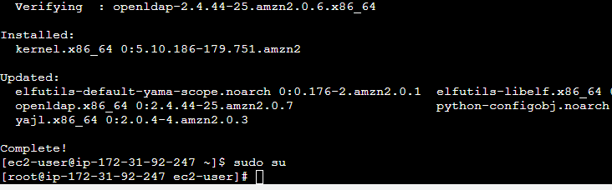

Use the command **" yum install docker -y” for install the docker tool**

Use the command **"docker –version”** for whether the docker is installed or not.

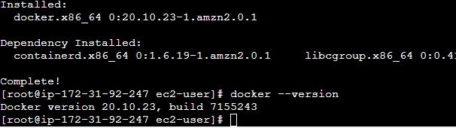

Use the command **“docker info”** for check Docker Daeman service status

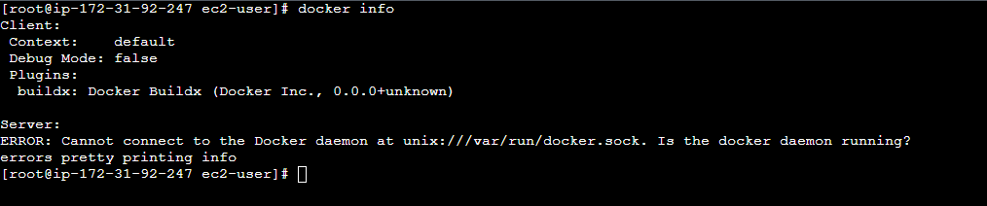

Use the command **“service docker start” & “service docker status”**

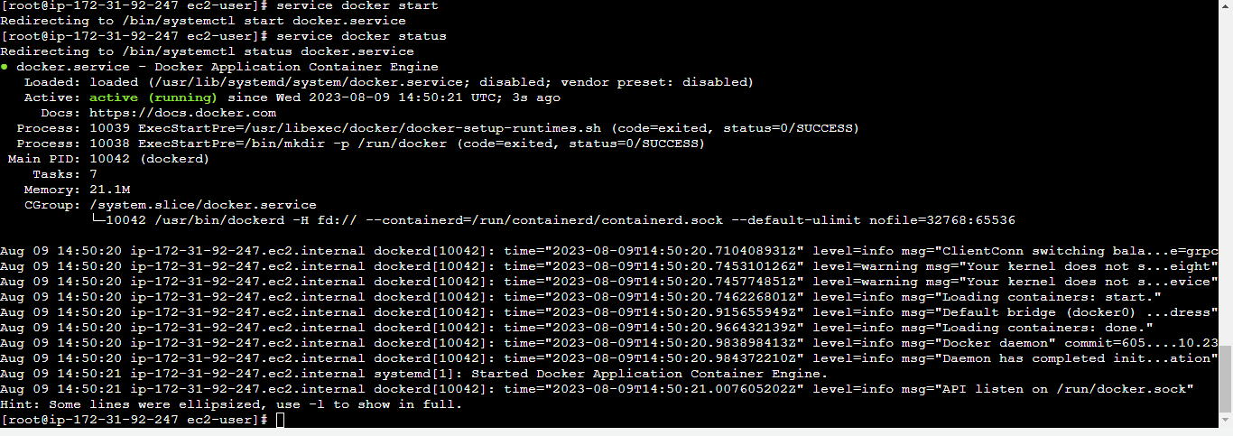

Now try the command for “docker info” to see the information about docker.

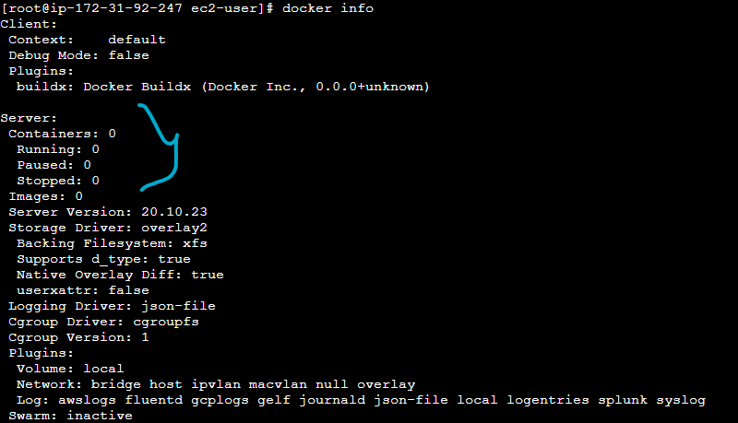

Now, how to create a container in docker.

EXPLAIN the process on docker container life cycle through google

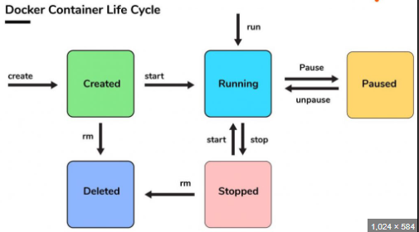

Command for docker containers:

docker create -it –name “name of container” ubuntu(images) /bin/bash

docker images – images downloaded locally from docker hub site

docker ps – running container shows

docker ps -a – stopped container shows

docker start “name of container” – start the container

docker stop “name of container” – stop the container

docker pull “name of image” – download the images from docker hub

docker rm “name of container” – remove the container

docker rmi “name of images” – remove the images

docker pause, docker unpause – pause and unpause the containers

docker login – site login

docker push – upload the image

docker tag – change the tag of image

docker help

Command “docker create -it --name Box1 ubuntu /bin/bash”

-it – stands for Interactive Terminal

/bin/bash – sh command

Box1 – Name of container

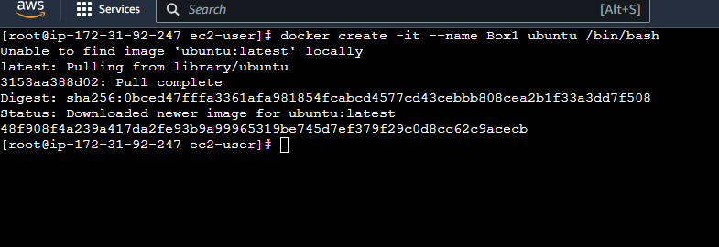

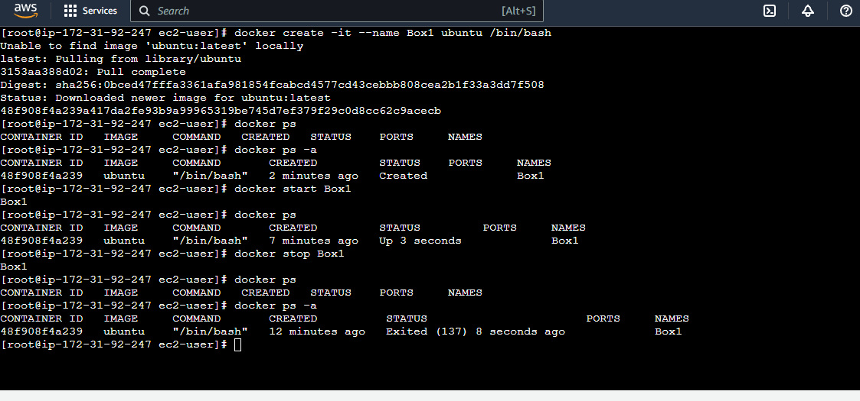

Remove the container and check the status

Recreate the container with same name “docker create -it –name Box1 ubuntu /bin/bash”

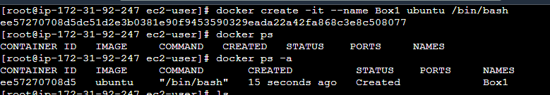

Use the command “docker run -it --name Box2 ubuntu /bin/bash” directly enter the container while created.

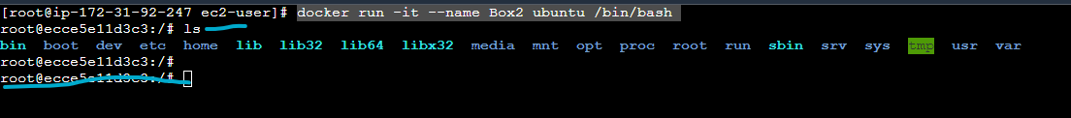

Presently, you have an inside of container where running on Ubuntu OS and do as your work here. “apt-get update -y” - ubuntu

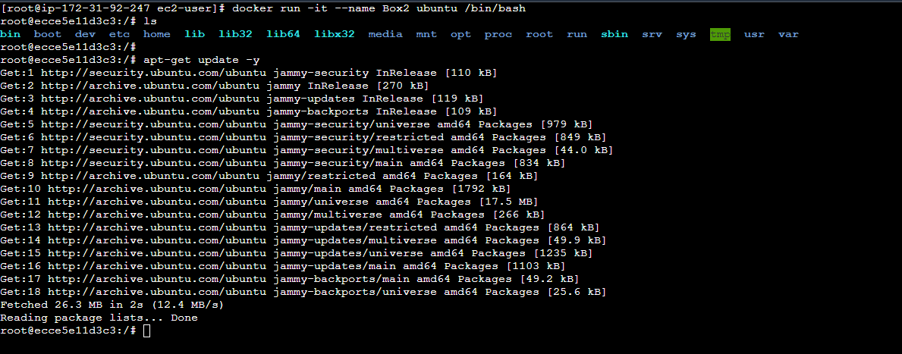

Use command “exit” for completely out the container, but it’s not advisable instead of use the Ctrl+p+q for you have to be exited the container but it will be running on background.

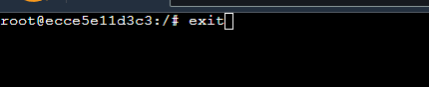

Check the Running containers, pause and unpause the containers by using the command “docker ps”, “docker pause”,“docker unpause”

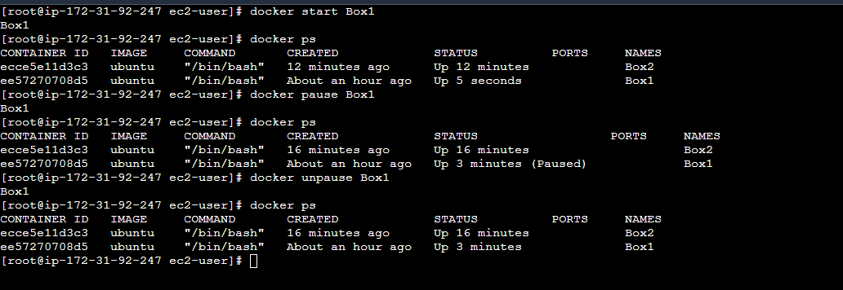

Use the command “docker attach ‘container name’” or “docker exec -it ‘container name’ /bin/bash” for enter the container from your linux instance to docker container.

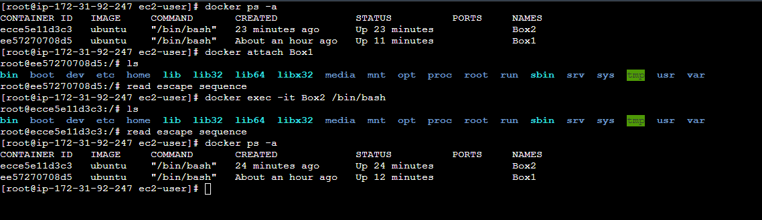

Use the command for remove the container “docker rm”

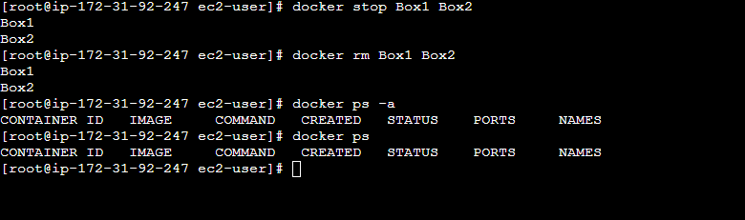

**Create an Image (Replicate the image to same environment to all the users with docker)**

Process: We have been 50 users to working a single project, they all want to access single image to all the docker machine, so there is a possible way to make an image(perquisite installed -java sql git) and distribute to all the user for performing the development activities.

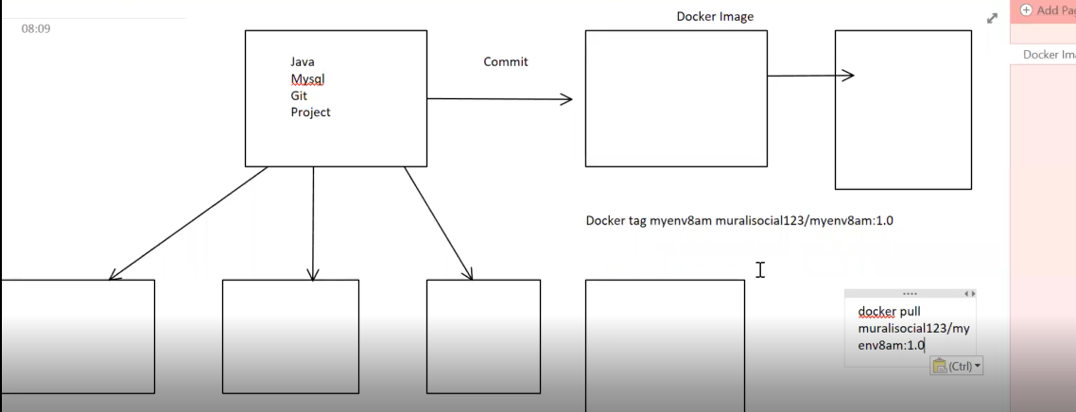

Create a Container loaded the Ubutnu image by using the command “docker run -it --name ProjectBox ubuntu /bin/bash”

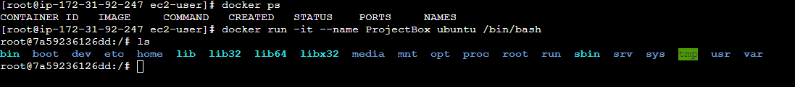

Install the pre-quisite for project – Java, git

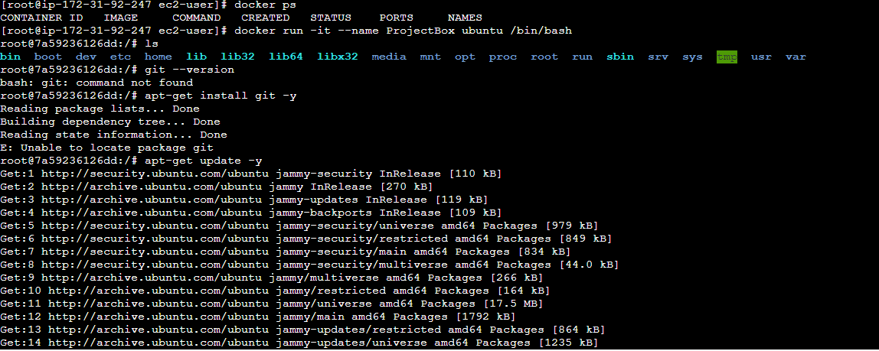

Installing git “apt-get install git -y” and check the version “git --version”

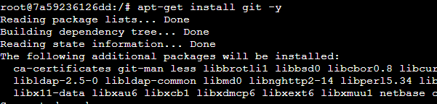

Installing Java “apt-get install default-jdk -y” and check the version “java --version”

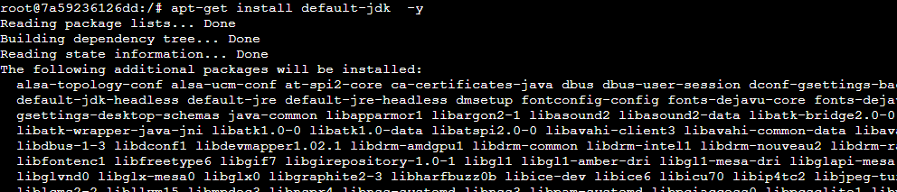

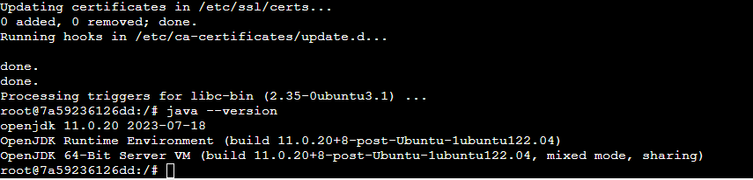

Installing mysql “apt-get install mysql-server -y” and check the version “mysql --version”

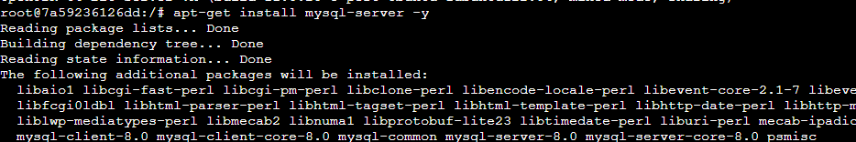

Check the version and also see the installed source directory

Before moving to create the image as a container, need to create a file in the container for reference.

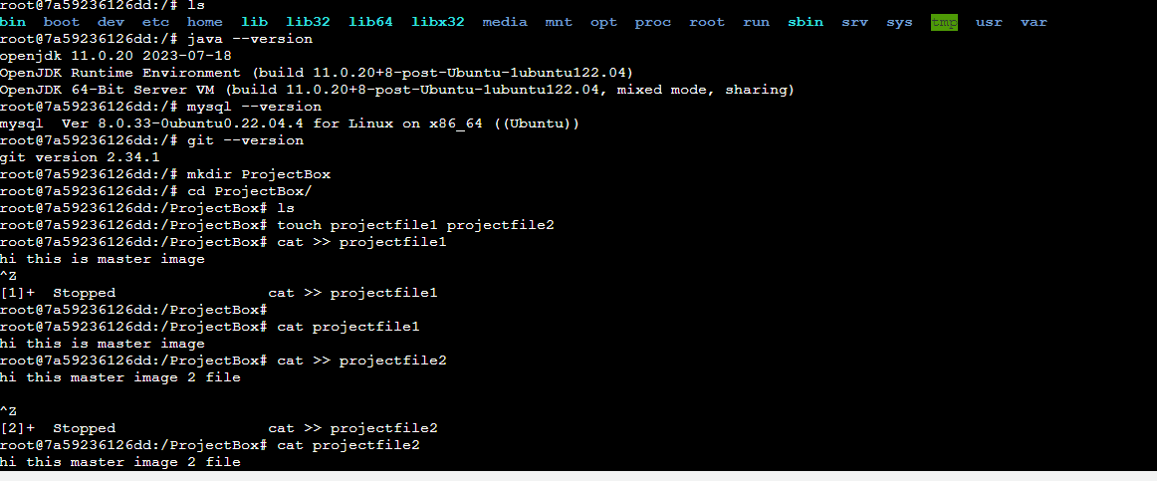

**A image is a read only template with the instructions for creation a docker container.**

**Steps to convert the container to image:**

1. **Switch back the container to linux instance (ctrl+p+q)**



1. **Next initiate the container to commit process before check whatever the containers are running.**



1. **Use the command “docker commit ‘conatiner name’ ’imagename(as you need)’” – convert image name as always lower case only and check the image size that might be sligther than bigger because we have installed the software here.**

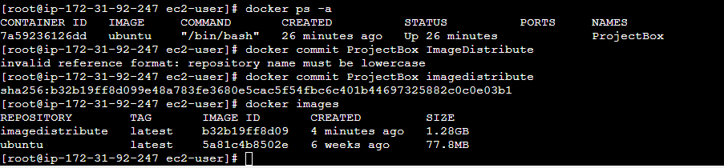

1. Next load the image to container for validate the image which have all the software are available.

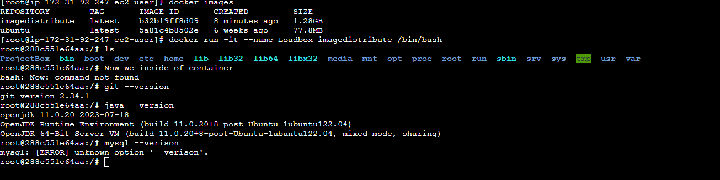

1. Login the docker hub

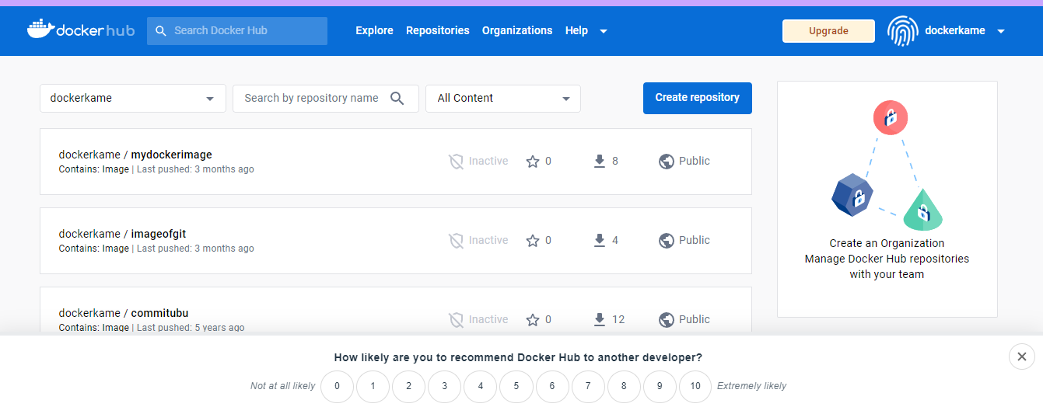

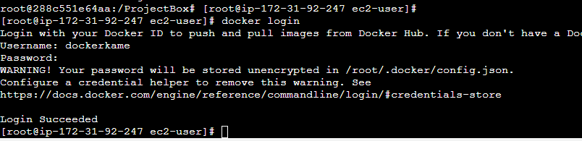

1. **Upload the docker image to docker hub repository for replication process and all the users need to be access the image.**

* **Change the tag name of image for identification or versioning**

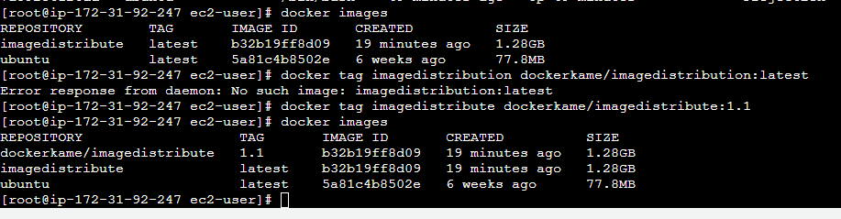

* Use the command “docker push ‘imagename’” for upload the docker image from local to docker hub repo.

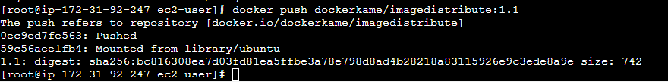

* Upload successfully, now the image will be reflecting the docker site.

Check the Tags and size of the file which have been compressed after upload to the docker site, always the docker file size is mb only. Use the docker pull command for download the image to anywhere.

